**Question no = 1 Look at the data given below . plot the data, find the outlier and find out mean , sigma , sigma^2**

**Answer no = 1**

**Mean = 0.3327**

**Sd = 0.1694**

**Var = 0.0287**

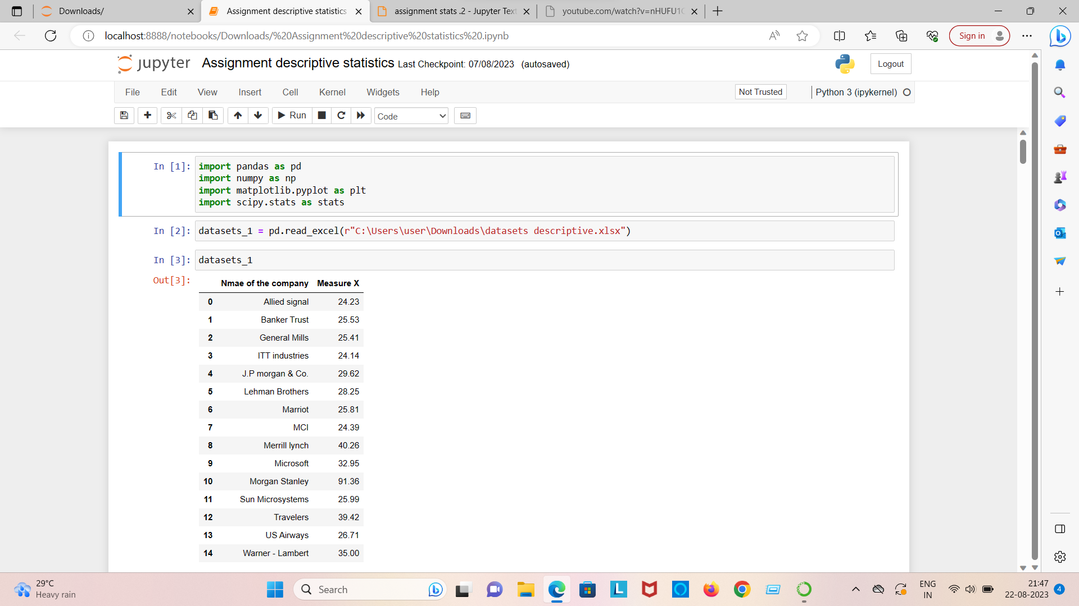

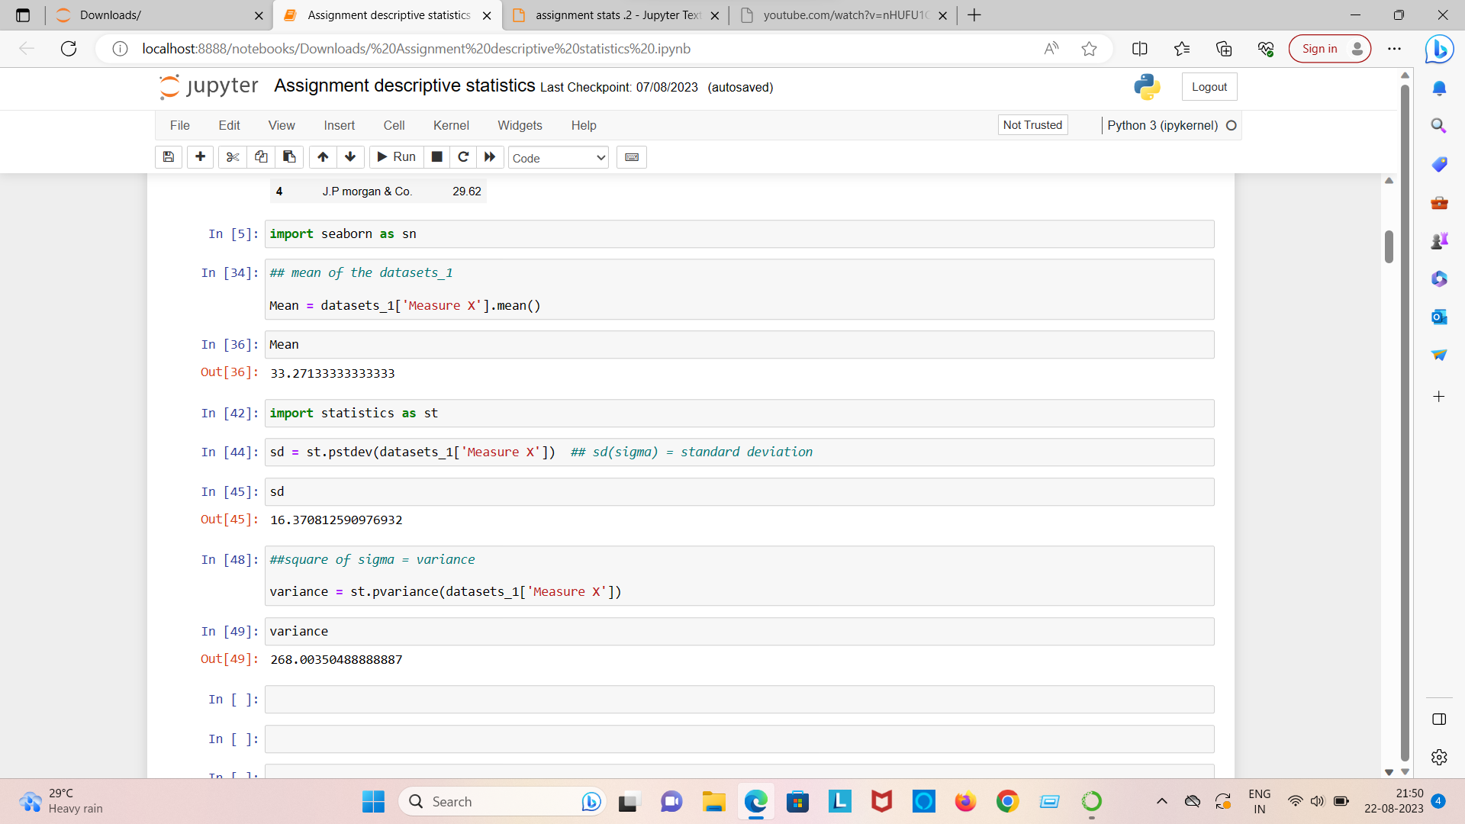

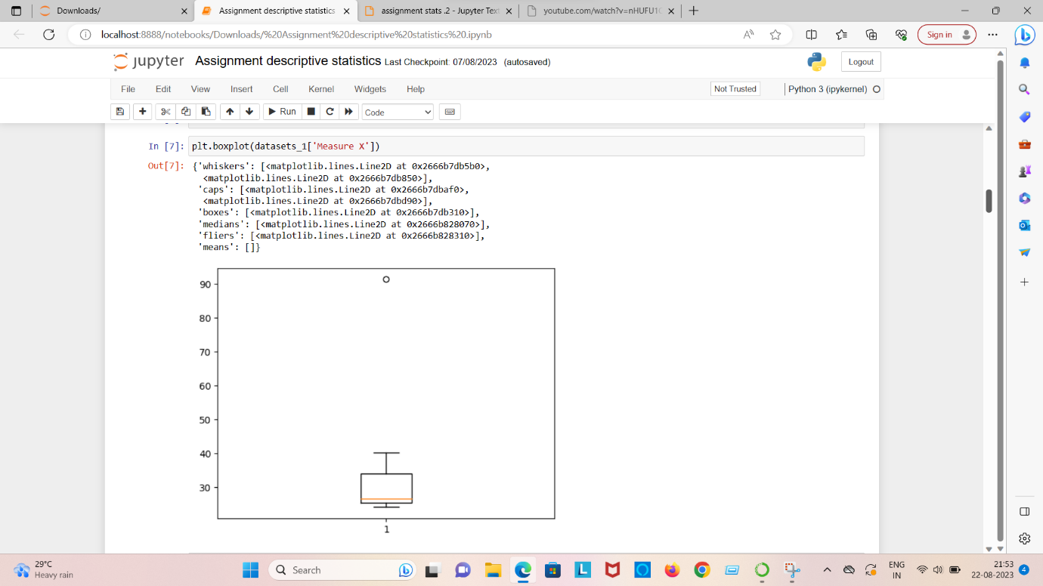

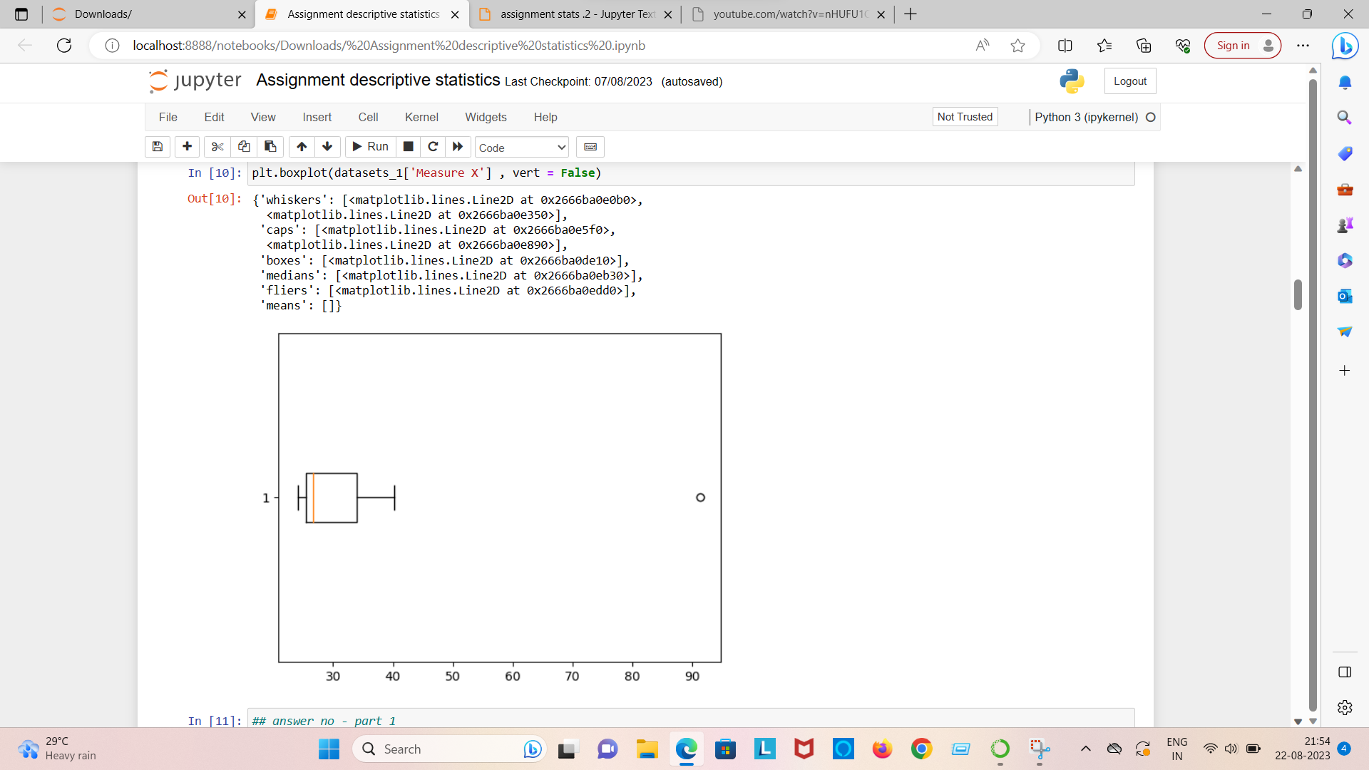

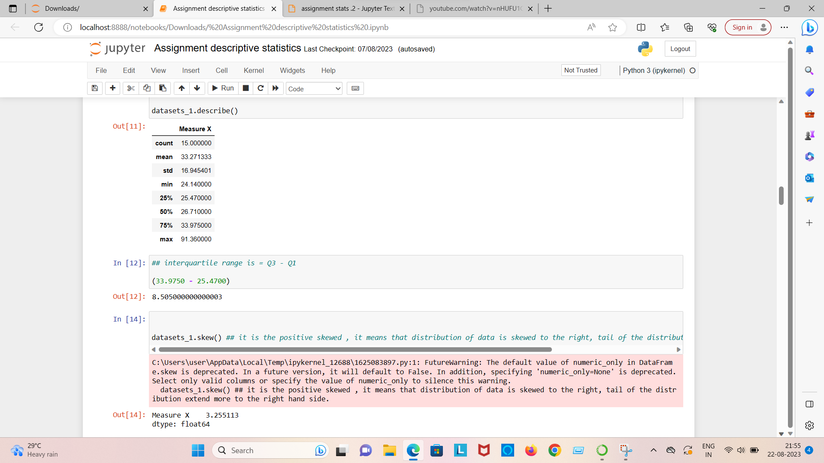

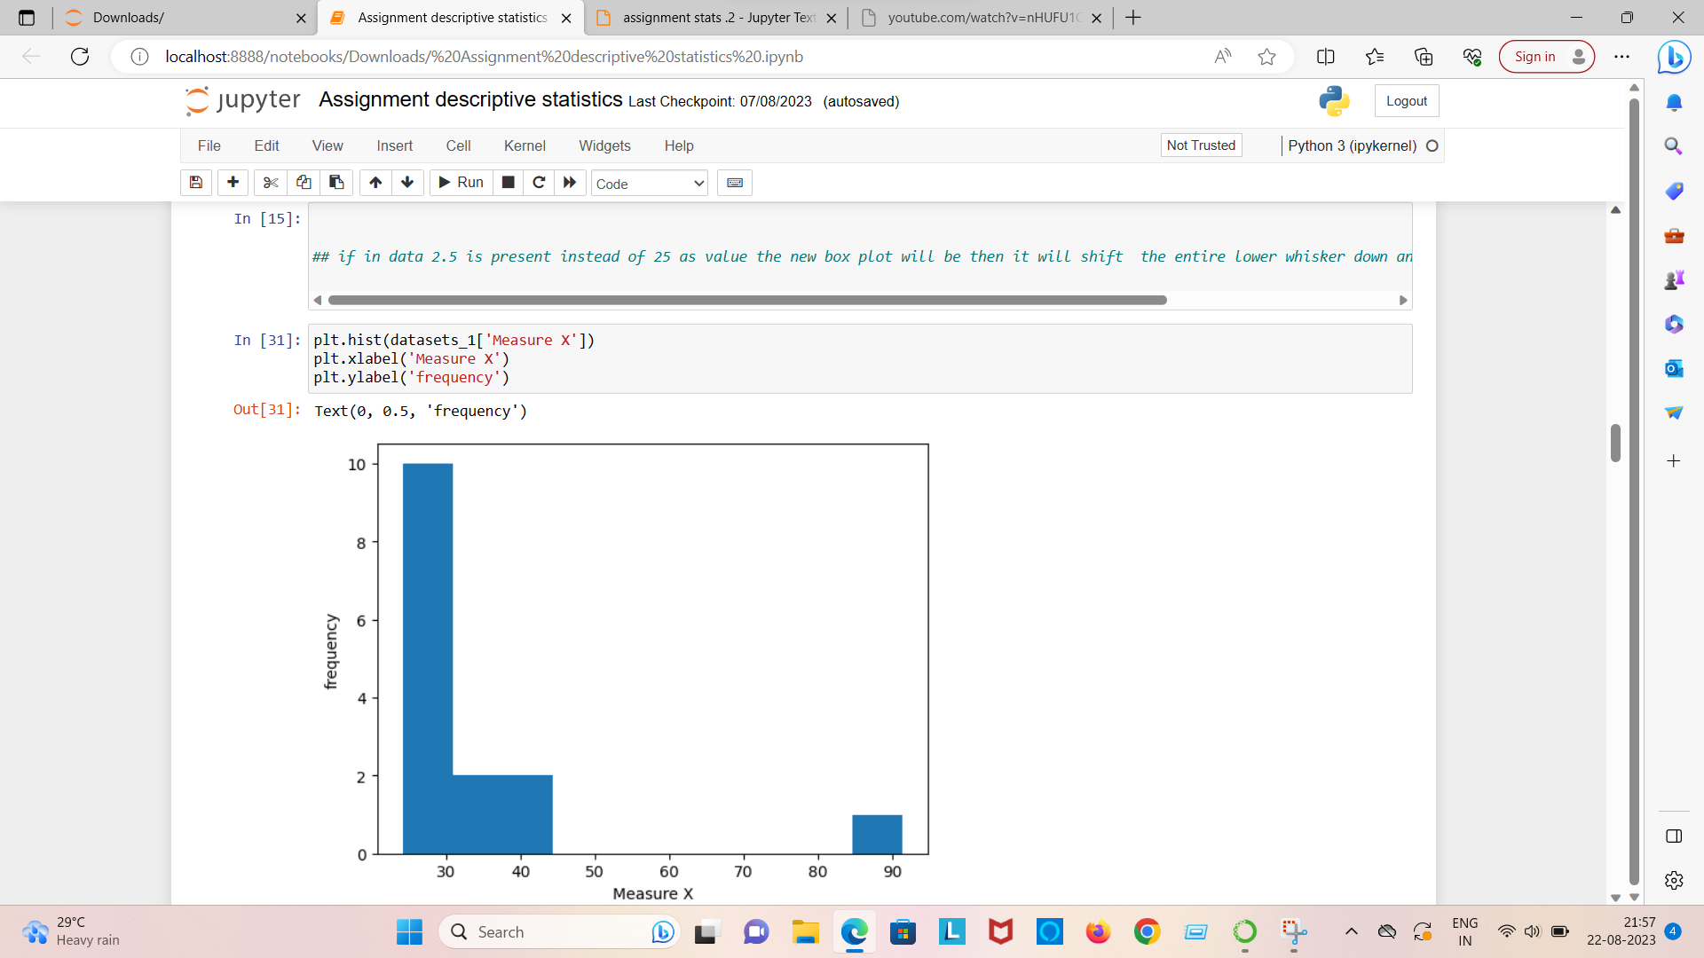

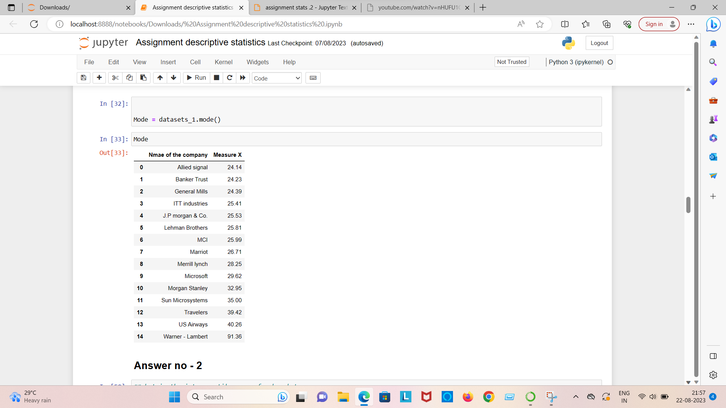

**Question no = 2 what is the inter quartile range of this data sets**

**What can we say about skewness of this datasets**

**If it was found that the data point with the value 25 is actually 2.5, how would the new box-plot be affected?**

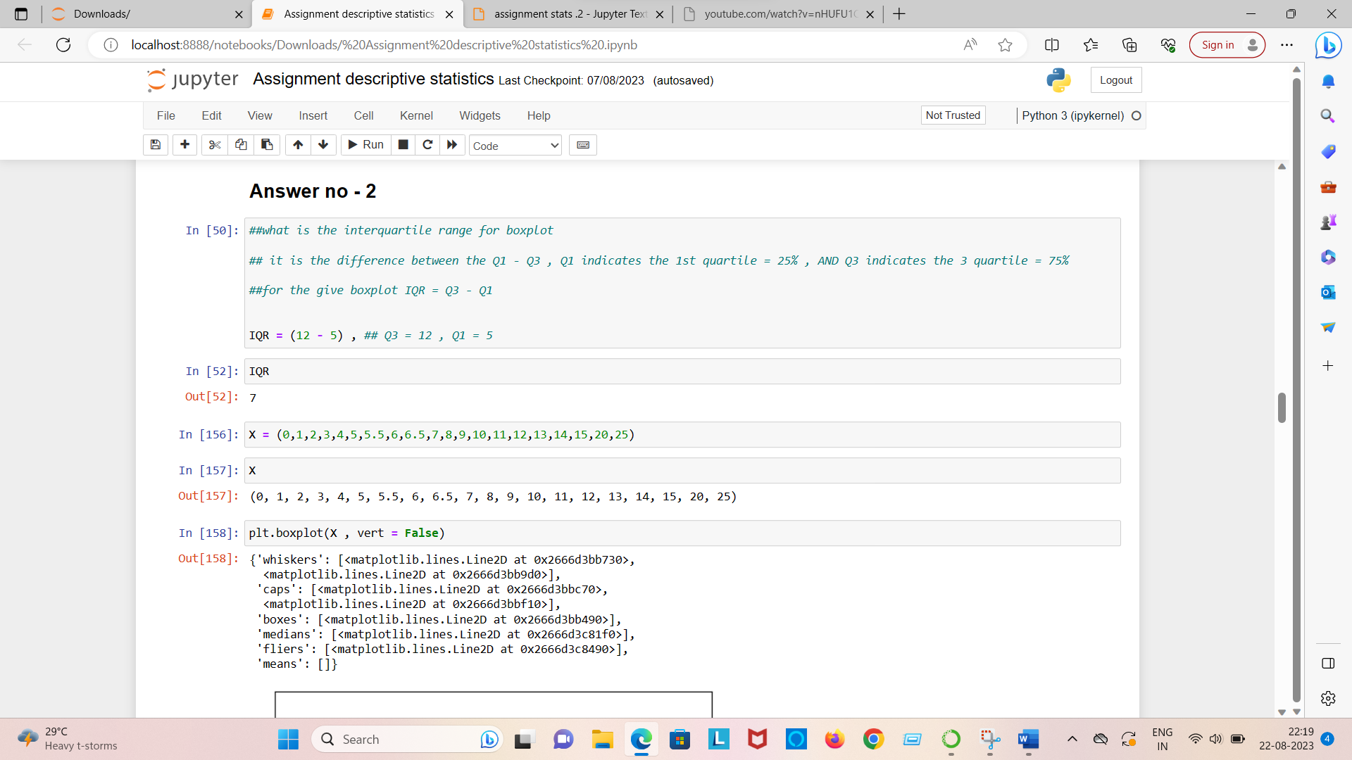

1. What is inter- quartile range of this dataset



Answer = There will be no outlier if the value of 25 was actually 2.5, subsequently, mean and median needs to be calculated to see if there is any shift in data

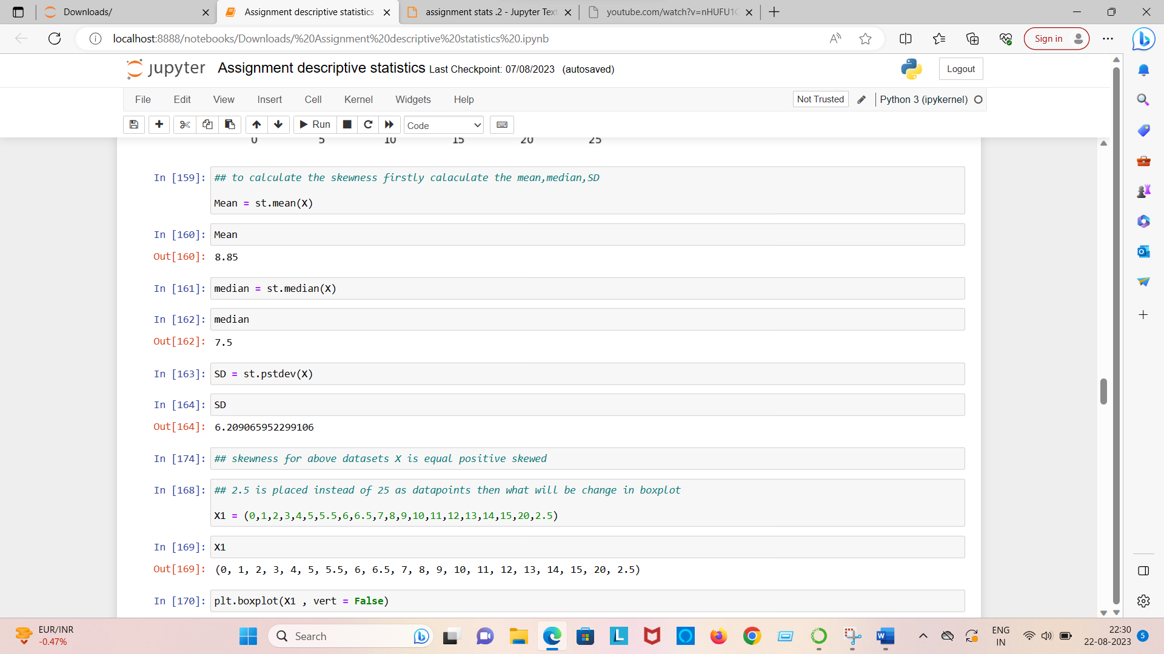

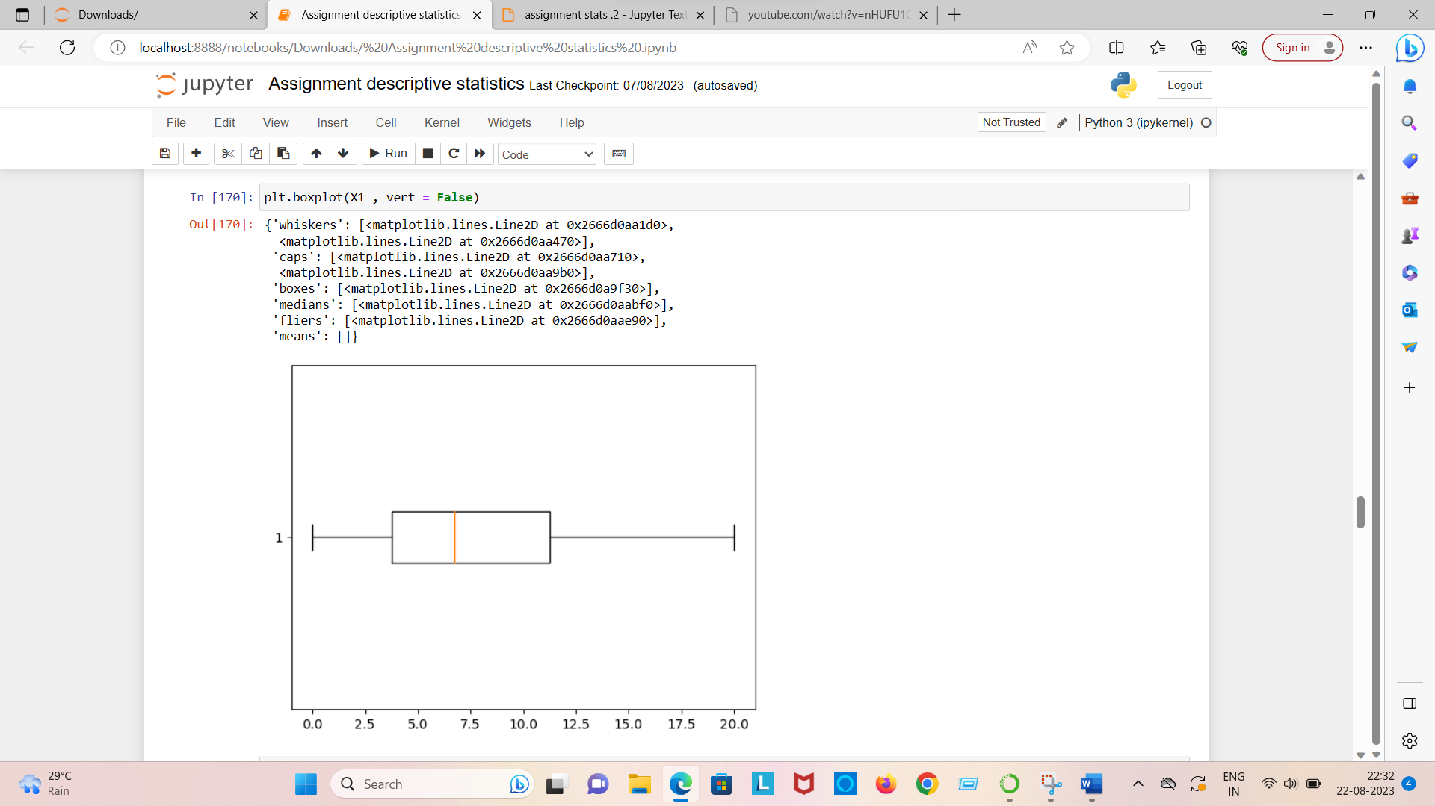

**Question no = 3 what would the mode of this dataset lie?**

**Comment on the skewness of the dataset**

**Suppose that the above histogram and the box plot in question – 2 are plotted for the same datasets. Explain how these graph complement each other providing information about any datasets.**

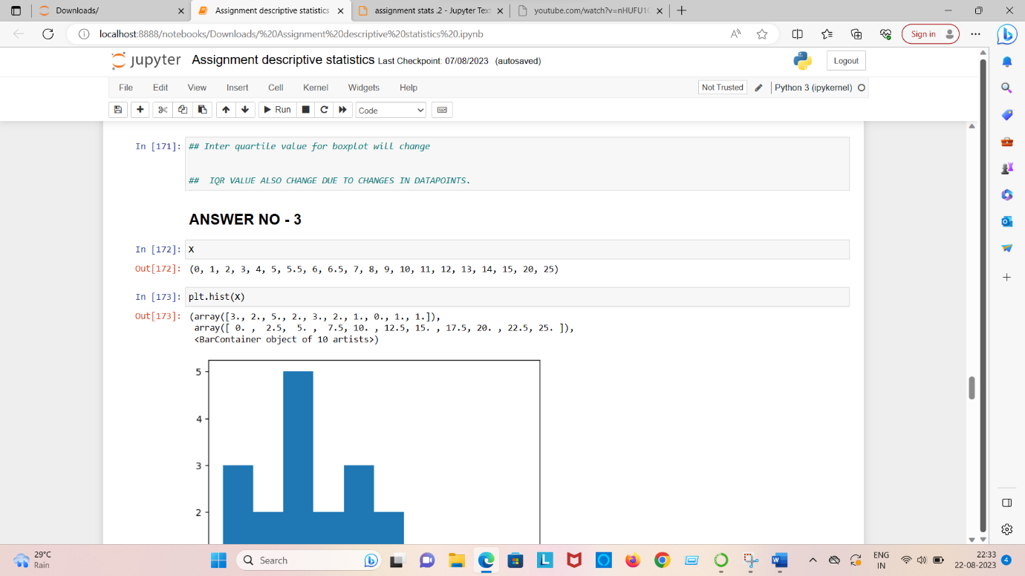

1. Answer = the mode can lie between 3 and 10 because majority of the entry in this range. To pin point the actual Mode we will have analyze the data.
2. Answer = skewness : Positive
3. Answer = There is an outlier of the value 25 and both the plot has positive skewness.

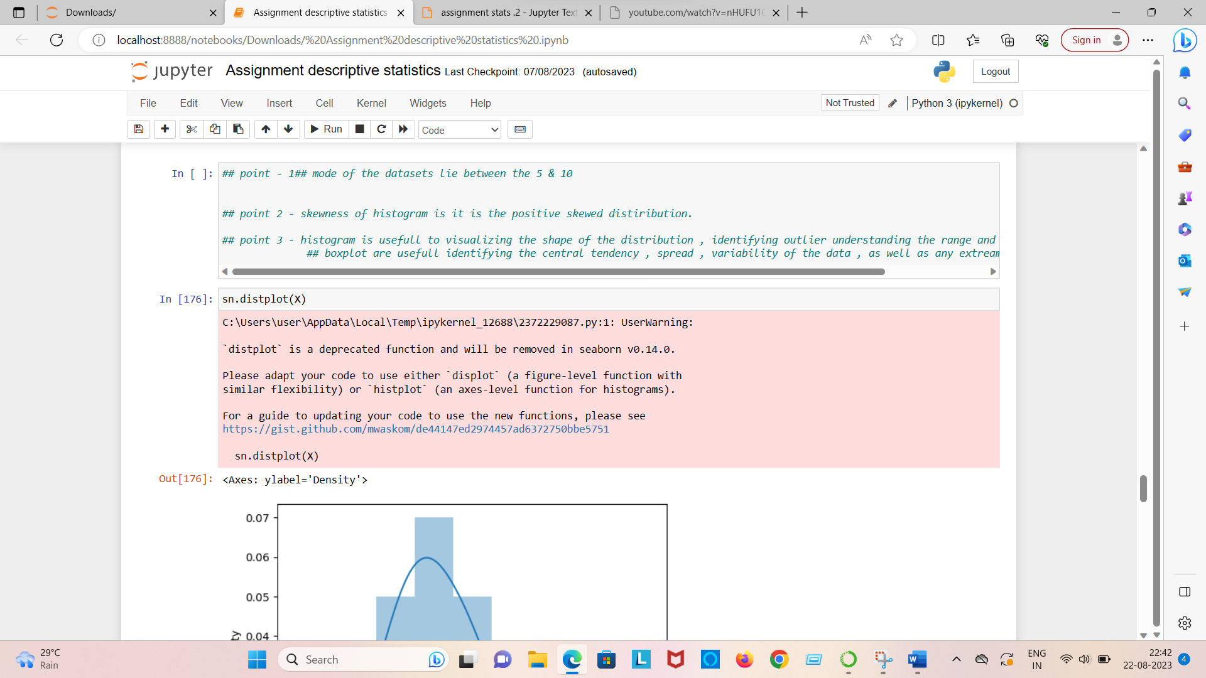

**Question no = 4 what is the probability that at least one in fove attempted telephone calls reaches the wrong number?**

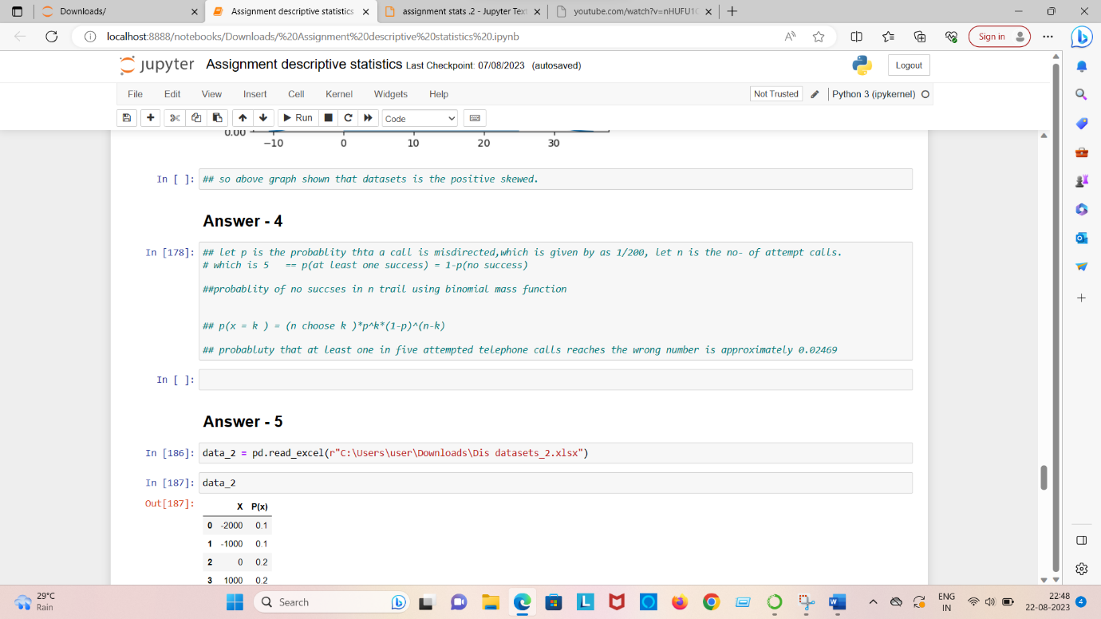

Answer = 4

X = probability of 1 call misdirected out of 200

Probability of occurring of X = 1/200

P(X) = 1/200

Probability of having at least one successful will be

1-P(x) = 1-1/200 = 199/200 = 0.967

As every event is independent of other event the probability will be

1-(0.967)^5

2% chance.

**Question no = 5 - 1.) what is most likely monetary outcome of the business venture?**

**2.) is the venture likely to be successful? Explain**

**3.) what is the long term average earning of business venture of this kind ? explain**

**4.) what is the good measure of the risk involved in a venture of this kind? Compute this measure.**

**Answer no = 5**

1. **What is most likely monetary outcome of the business venture**

**Ans = 2000$ as highest probability of occurrence**

1. **Is the venture likely to be successful**

**Ans = there is 60% chance that venture is successful(0.3+0.2+0.1 = 0.6=>0.6*100=>60%).**

1. **What is the long term average earning of business venture of this kind? Explain**

**Ans : (-2000*0.1)+(-1000*0.1)+(0*0.20)+(1000*0.20)+(2000*0.30)+(3000*0.10) = 800**

**The long term average earning for these type of ventures would be around $800**

